ADBMS LAB

LAB CYCLE - 2

SUBMITTED BY : ARYA M.S

ROLL NO : 212 MCA S2

PROGRAM -1

**AIM:** . Construct PL/SQL code for sample databases.

**Sql code:**

create database student;

use student;

drop table Stud;

show tables;

create table Stud(

s_id VARCHAR(5),

Stud_NAME VARCHAR(10),

M1 INT,

M2 INT,

M3 INT,

Status VARCHAR(8)

);

call onmark('1','Anju',98,80,81);

call onmark('2','Ann',98,50,41);

call onmark('3','John',98,60,81);

call onmark('4','Joe',38,30,31);

select *,percentage(M1,M2,M3) from Stud;

**stored procedure:**

CREATE DEFINER=`root`@`localhost` PROCEDURE `onmark`(s_id varchar(5),Stud_NAME varchar(10),M1 int,M2 int,M3 int)

BEGIN

IF(M1<40 OR M2<40 OR M3<40) THEN

INSERT INTO Stud values(s_id,Stud_NAME,M1,M2,M3,'FAIL');

END IF;

IF(M1>40 AND M2>40 AND M3>40) THEN

INSERT INTO Stud values(s_id,Stud_NAME,M1,M2,M3,'PASS');

END IF;

END

**Function.sql:**

CREATE DEFINER=`root`@`localhost` FUNCTION `percentage`(M1 int,M2 int,M3 int) RETURNS int(11)

BEGIN

declare percentage float;

RETURN (M1+M2+M3)/3;

END

**OUTPUT**

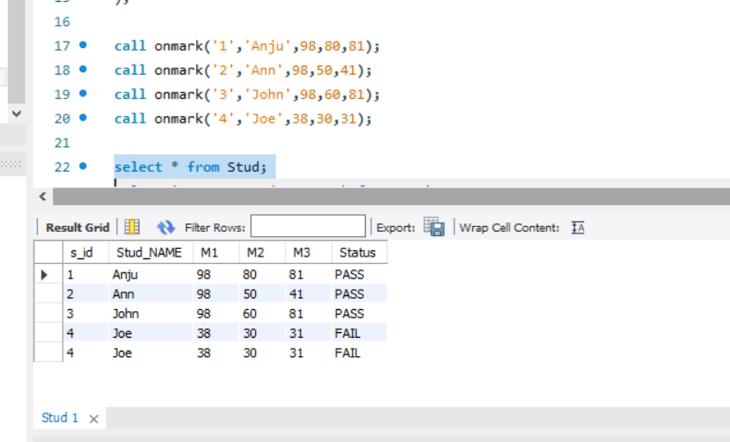

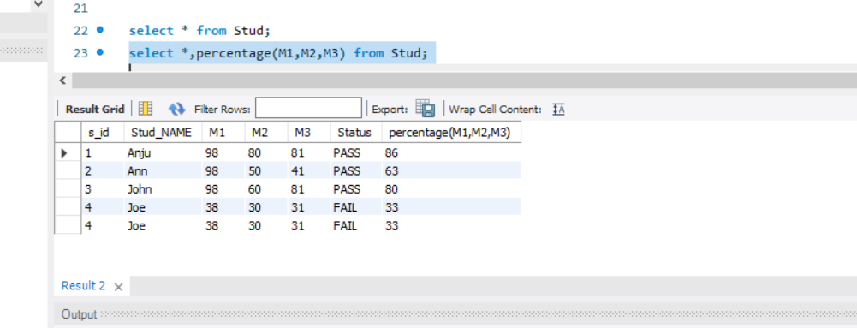

**PROGRAM -2**

**AIM:** . Construct Trigger and cursor for sample databases.

**Trigger:**

create database college_employee;

use college_employee;

create table new_employee(emp_id int,emp_name varchar(20),emp_department varchar(20));

insert into new_employee values(101,'Riya','MCA');

insert into new_employee values(102,'Rekha','CS');

create table department_MCA(dept_id int,dept_name varchar(20),dept_emp varchar(20));

create table department_cs(dept_id int,dept_name varchar(20),dept_emp varchar(20));

insert into new_employee values(105,'Kevin','MCA');

select * from new_employee;

select * from department_MCA;

select * from department_cs;

drop trigger new_employee_AFTER_INSERT;

-- trigger

/*

CREATE DEFINER=`root`@`localhost` TRIGGER `new_employee_AFTER_INSERT` AFTER INSERT ON `new_employee` FOR EACH ROW BEGIN

if(new.emp_department='MCA') then

insert into department_MCA set

dept_id=new.emp_id,dept_name=new.emp_name,dept_emp="Assist proff filled";

end if;

if(new.emp_department='CS') then

insert into department_cs set

dept_id=new.emp_id,dept_name=new.emp_name,dept_emp="Assist proff filled";

end if;

END

*/

**Cursor:**

create database college;

use college;

drop table library;

create table library(shelf_no int,category varchar(10),book_name varchar(20));

insert into library values(101,'Topology','Real Analysis');

insert into library values(102,'Algebra','Linear Algebra');

insert into library values(103,'Analysis','Complex Analysis');

insert into library values(104,'OR','Operations Research');

insert into library values(106,'NumberSys','AbstractAlg');

create table book_by_order(book_shelf int,book_category varchar(20),bookname varchar(20));

select * from library;

call book_details();

/*

CREATE DEFINER=`root`@`localhost` PROCEDURE `book_details`()

BEGIN

declare book_shelf int;

declare bookname varchar(20);

declare book_category varchar(10);

declare C_finished integer default 0;

declare C1 cursor for select shelf_no,category,book_name from library;

declare continue handler for not found set C_finished = 1;

open C1;

book_details:loop

if C_finished=1 then

leave book_details;

end if;

if C_finished = 0 then

Fetch from C1 into book_shelf,book_category,bookname;

if book_category = 'OR' then

insert into book_by_order values(book_shelf,bookname,book_category);

end if;

end if;

end loop;

close C1;

END

*/

OUTPUT

Trigger:

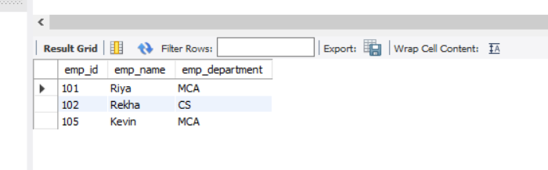

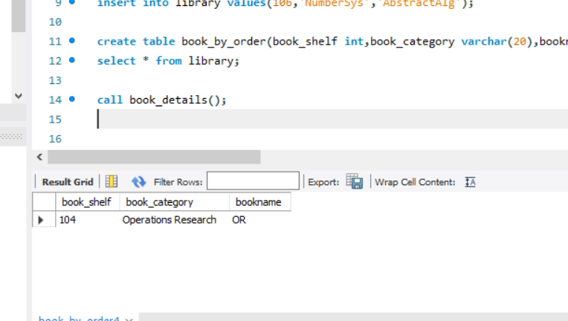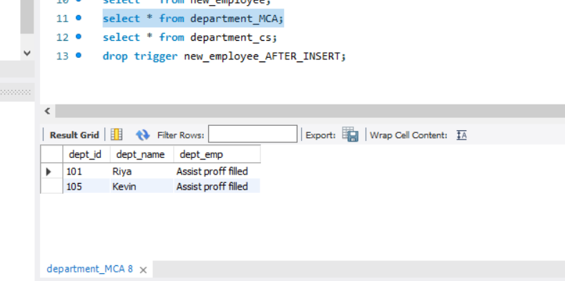

Cursor:



**PROGRAM -3**

**AIM:** . Construct Trigger for shop databases for updating each purchase detail in the product database.

**Code:**

create database shop;

use shop;

drop table product;

drop table purchase;

create table product(p_id int,p_name varchar(20),quantity int,price int);

create table purchase(pid int ,p_nm varchar(20),purchased_quant int);

insert into product values(1,'Soap',5,35);

insert into product values(2,'mirror',3,60);

insert into product values(3,'comb',2,30);

insert into product values(4,'Pen',20,5);

select * from product;

insert into purchase values(2,'mirror',1);

insert into purchase values(4,'Pen',4);

select * from purchase;

/*

CREATE DEFINER=`root`@`localhost` TRIGGER `purchase_AFTER_INSERT` AFTER INSERT ON `purchase` FOR EACH ROW BEGIN

set sql_safe_updates= 0;

update product set

quantity=quantity-new.purchased_quant where p_name= new.p_nm ;

END

*/

**Output:**

